**Lab 8**

**Configure VPC – for Associate**

In AWS console, click “VPC”.

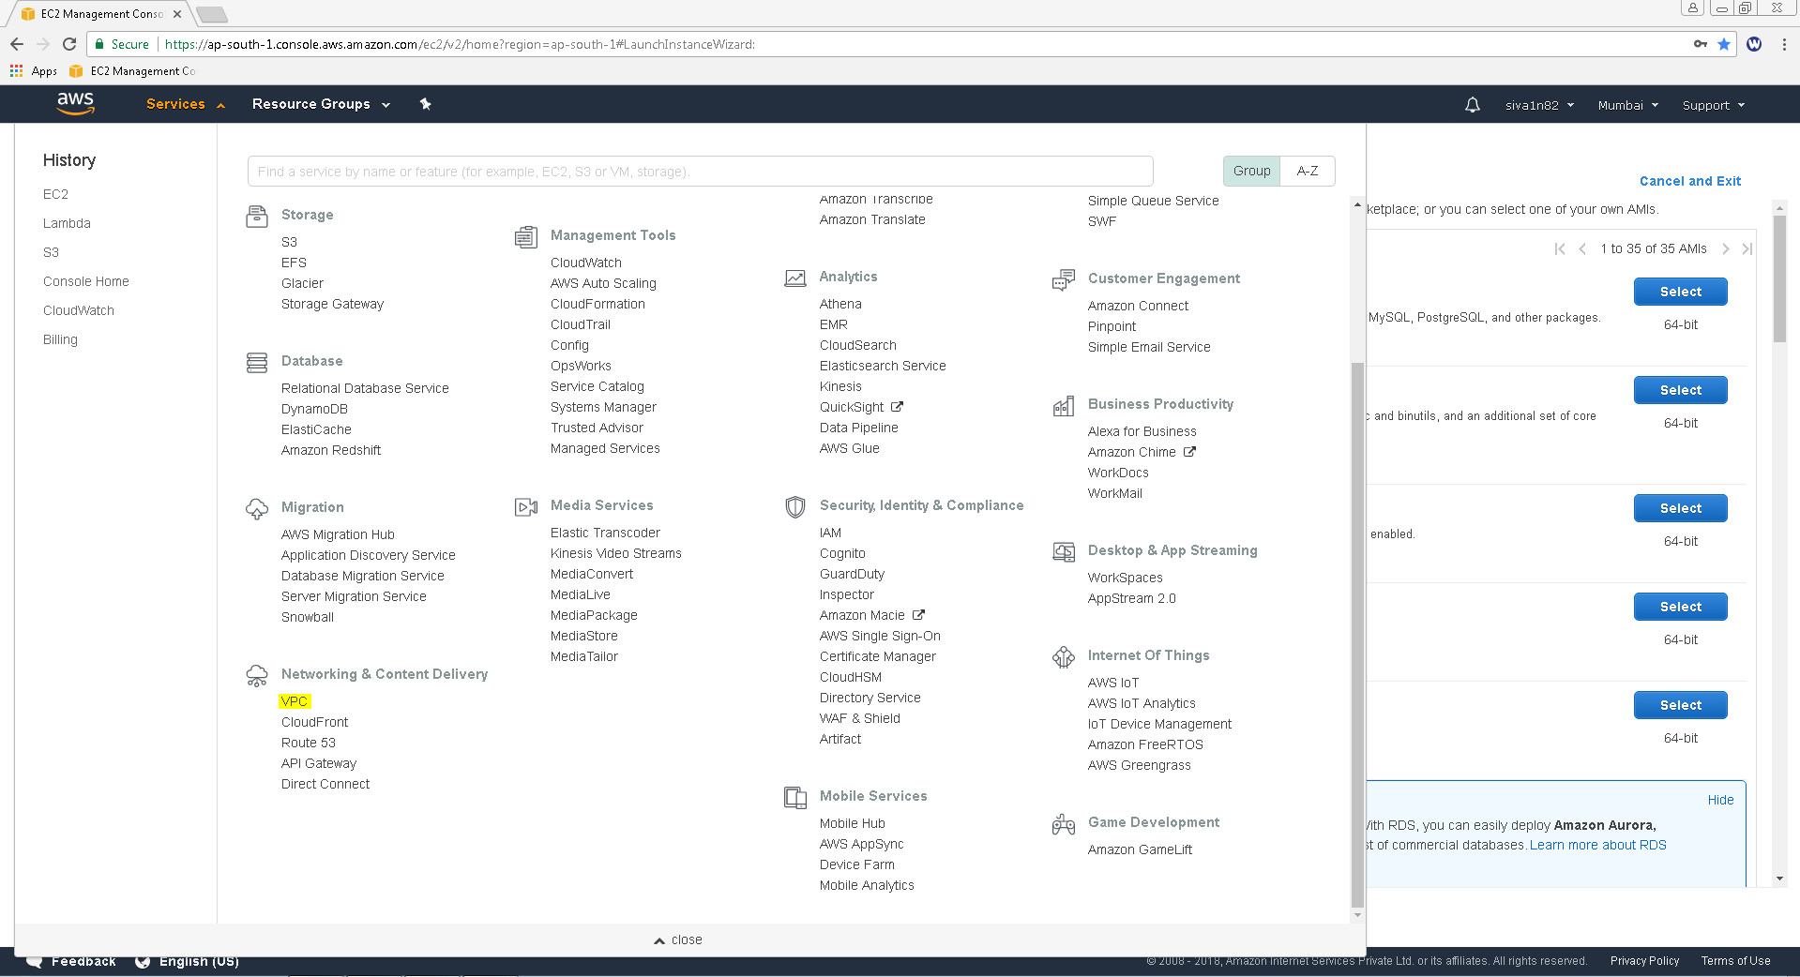

Click “Create VPC”.

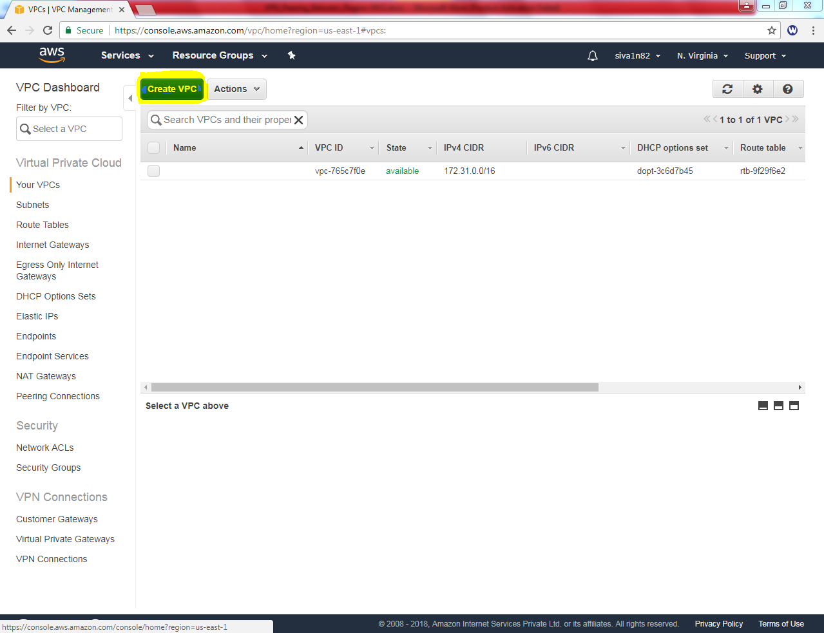

While create VPC, **Name tag** as “Sansbound_VPC” and **IPV4 CIDR Block** as 10.0.0.0/16

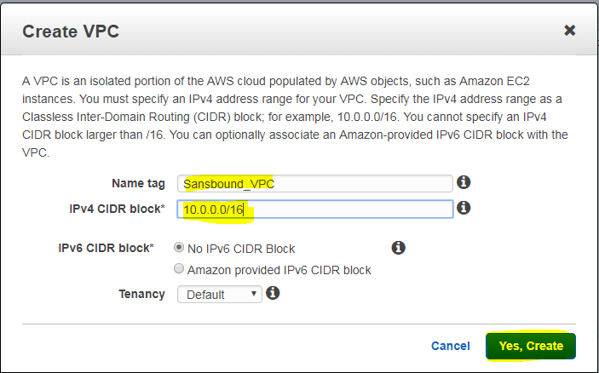

Then click “Create”.

Then We need to create subnet for the VPC.

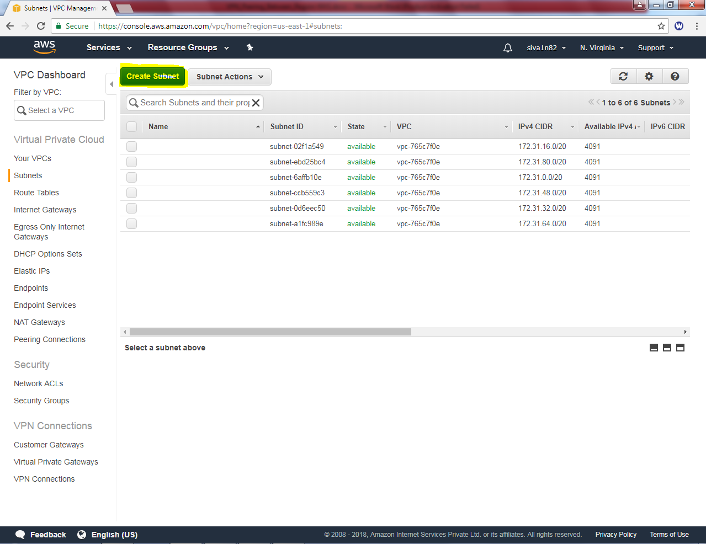

While creating subnet, **Name tag** as Sansbound_Public_subnet, **VPC** as “Sansbound VPC” **Availability zone** – 1B (Optional) and **IPV4 CIDR Block** as 10.0.2.0/24.

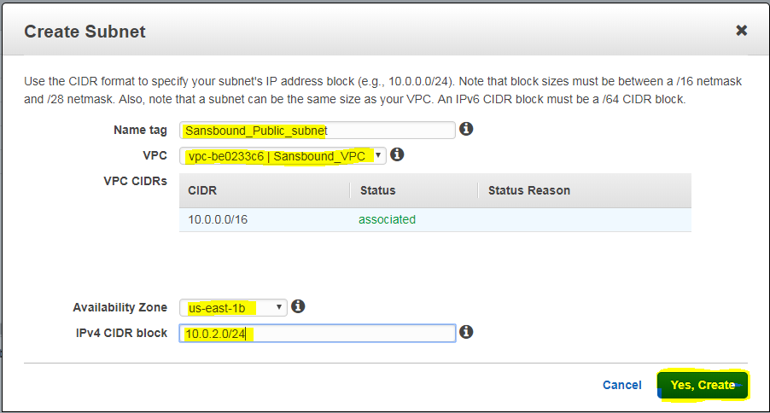

Then click “Yes, create”.

Now we need to create an instance (windows 2016) in North Virginia.

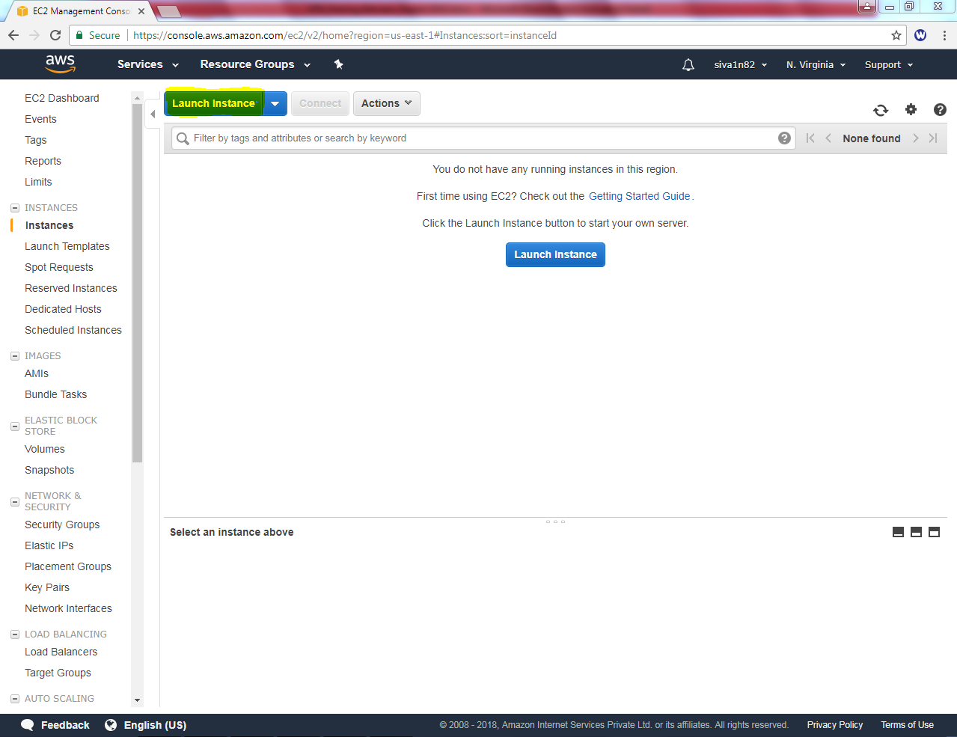

Select “Microsoft Windows Server 2016 Base”

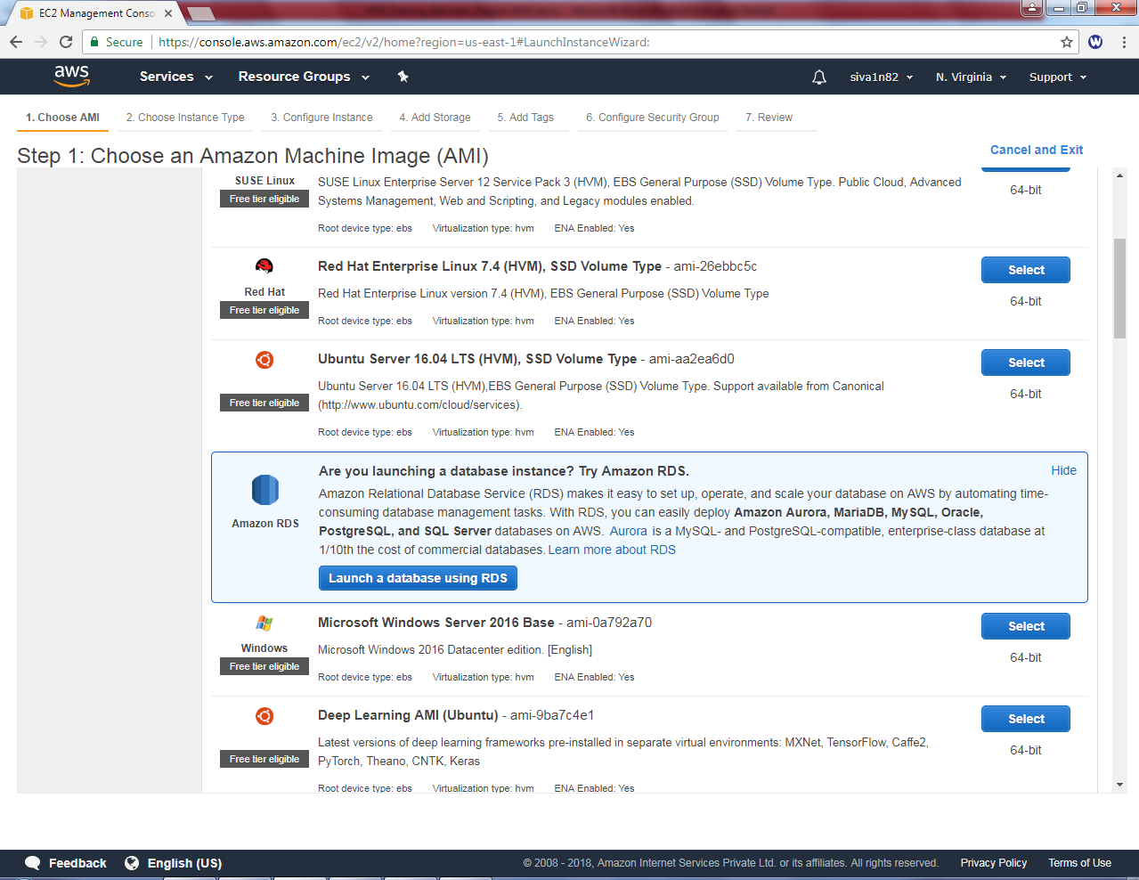

Select “t2.micro”.

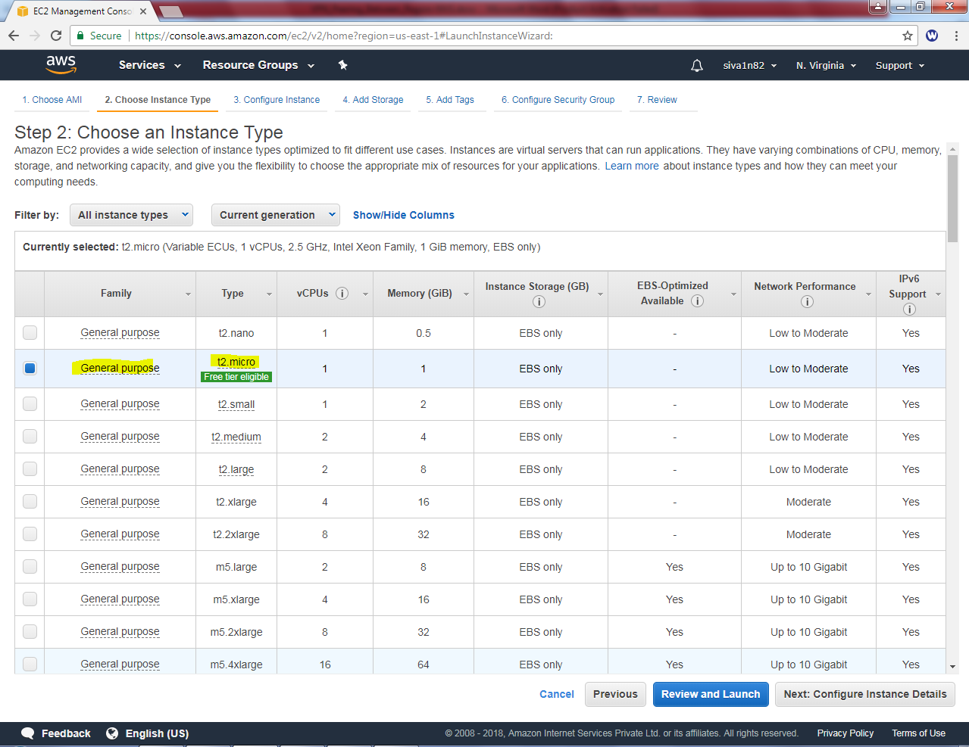

**Select “Sansbound VPC” , subnet: Sansbound_Public_Subnet and Auto assign “Enable”.**

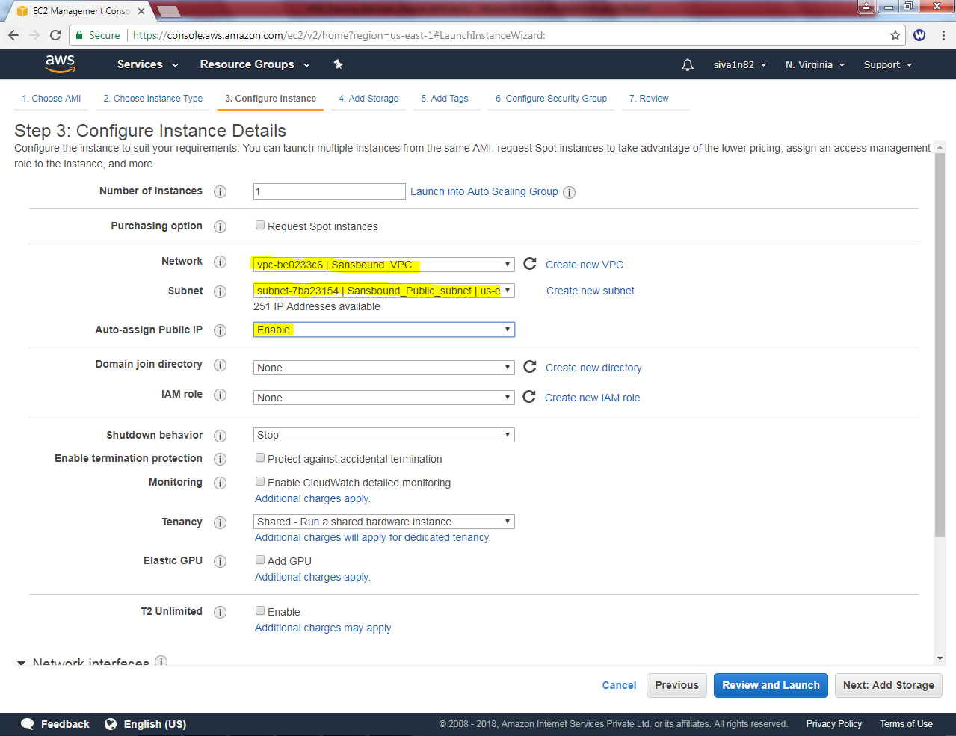

Leave default settings and click “Next”.

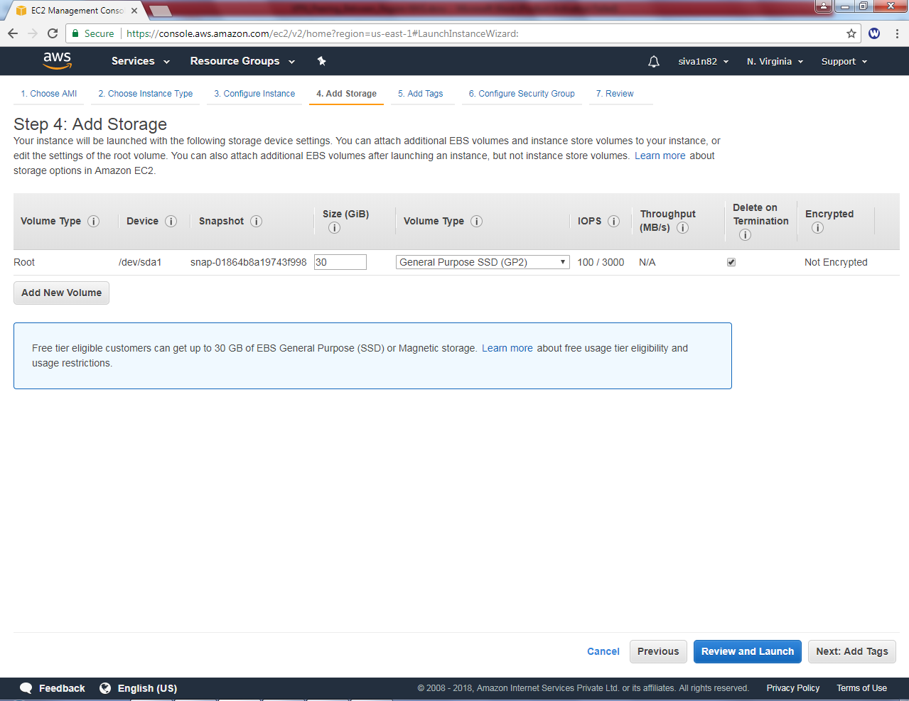

In Key as name, Value as North Virginia Public Internet

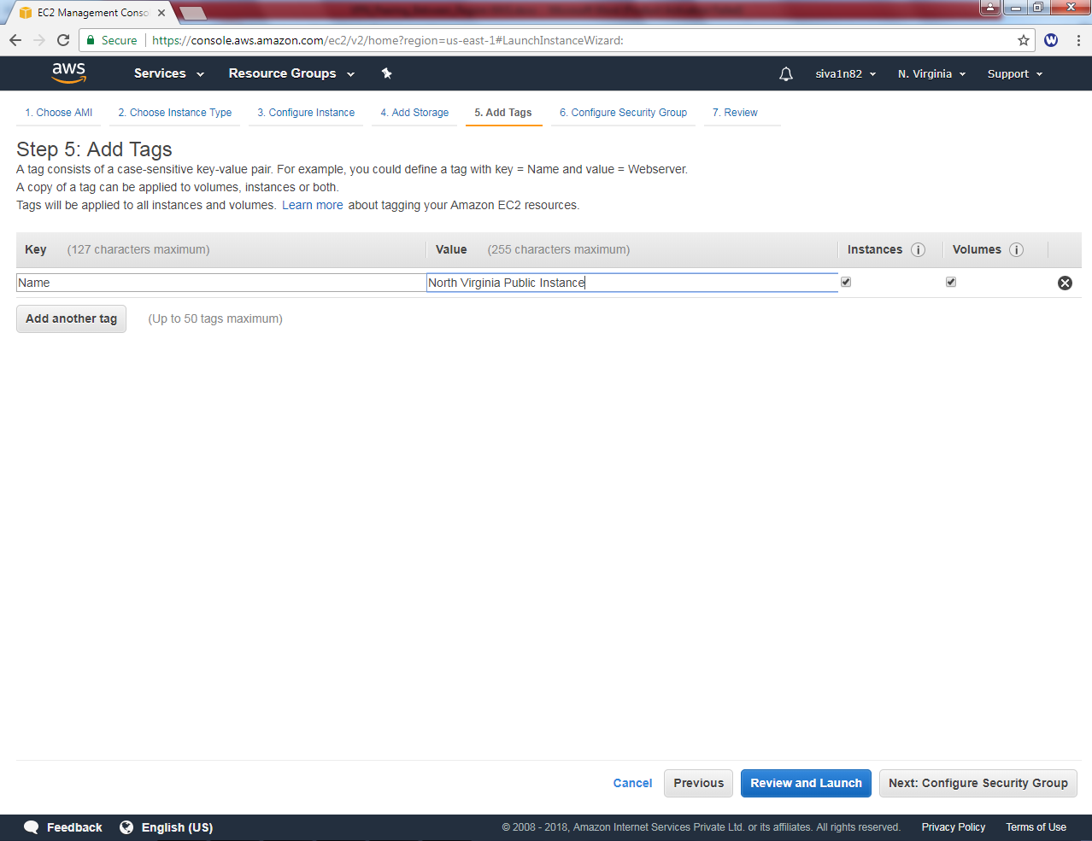

Create a security group as “NVG_Public_Sec-Group”.

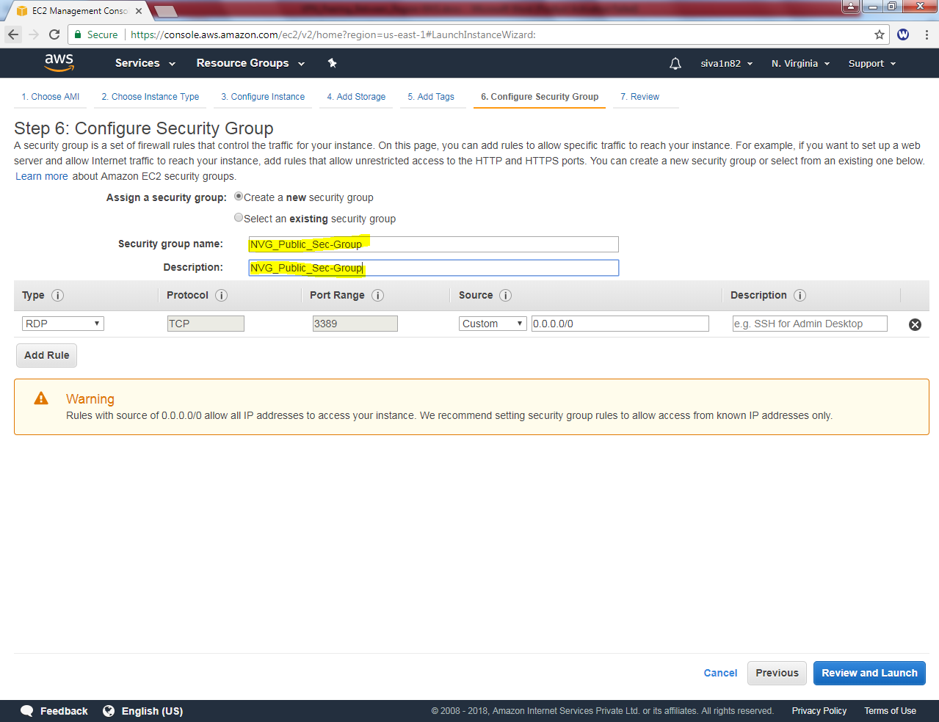

Leave the settings default.

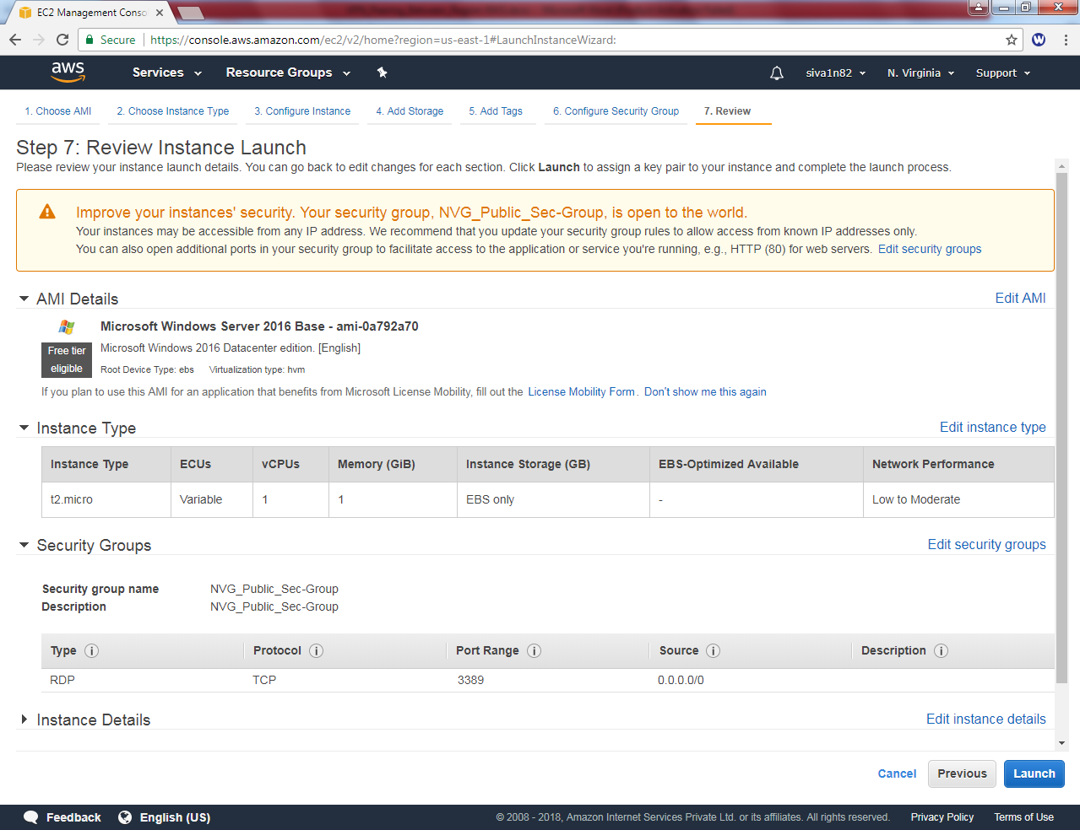

Click “Choose an existing key pair” / create an new key pair as per your requirement.

**Click Launch instance.**

